GUVI Task 3

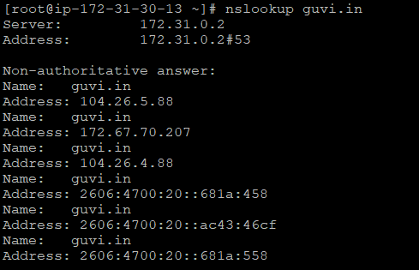

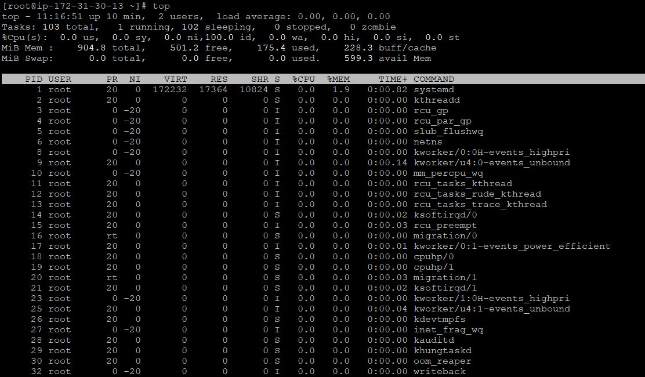

As ss -tulnp | grep 9000 doesn’t return anything it means port 9000 is not open.

